Sequence Diagrams(Reqs 21-24) erdi meÇi

UC_21: request account suspension

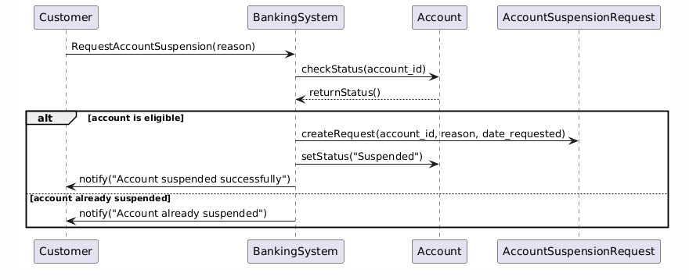

UC_22:chatbot assistance for faq’s

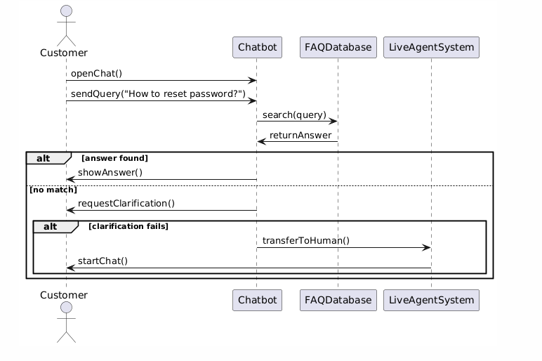

UC_23: auto-logout after inactivity

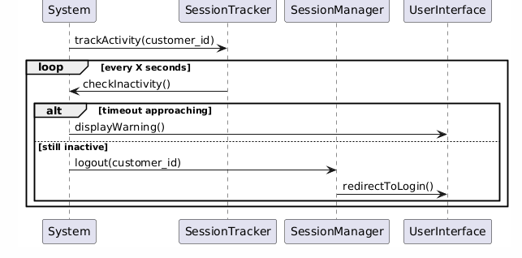

UC_24: reset customer login credentials

